Title: 2008 Crisis
Subject: EEP 14

1. The 2007 Crisis  A. Origin: The Globalziation Shock  B. The house price bubble and mortgage boom  C. Mortgage crisis  D. Financial crisis  E. Economic crisis  F. the way out  a. Monetary Policy and Fiscal Policy response  Appendix: How leverage works | The strong $ work against the expansionary mp in => i has to be kept at low levels for a long period. This determines sustained Inv, huge surge in house prices both due to domestic and foreign K accumulation (I rates are low for buying treasuries).  Supply shock: From 90s, globalization allowed US to import inputs and goods at low p particularly from China (huge economies of scales and low L costs  Domestic producers outcompeted + downward pressure on π (“weapon of mass disinflation”)  Exp mp => i $↓$ => I abroad more attractive  K should float out from Us/Eu to dev nations => dollar depreciation => foreign goods become more expensive = raise π  This does not happen bc emerging economies (china, oil exporting countries) experience significant CA surpluses.  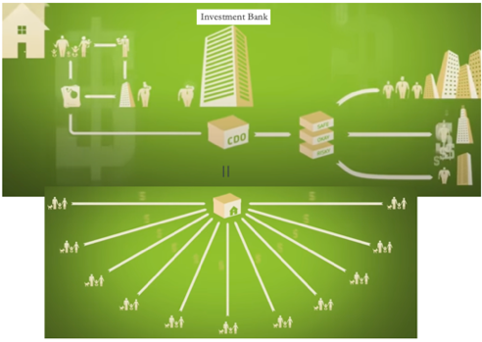  Until House value is increasing:  A. People want a lot of houses  B. Banks can borrow low and make a lot of money: leverage a lot, lend a lot also at at very favourable conditions even to those who should not qualify for it (no down payment, no proof of income).  FED starts to increase i (2004-2005).  PPl start to default. High rates less D for houses + more defaults as rates rise => higher S as banks start selling collateral houses! => prices start decreasing => even more ppl start defaulting (cost of mortgage > value of the house)  Huge losses for banks => Defaluts (Fannie Mae & Freddie Mac in distress, Bear Sterns bailed out, Lehman Brothers not bailed out! + Several Eu banks)  Inter-banking interest rates soar (+ out of control: divergence between interbanking rate and CB policy rate):  - Credit crunch (no liquidity): large increase in borrowing rates + drain of available loans => lower investment => lower gdp growth  - Loss of wealth: the value of fin assets and houses drops => lower consumption =>=> lower gdp growth  - Decrease in confidence: precautionary saving => negative effect from expectations on Consumption and investment (C smoothing)  - Trade collapse: Demand decreasing also abroad (usually useful to rely on foreign demand)+ lack of financial itermediation => lower exports  => Gdp fall, risk of fin mkt collapse  In October 2008, EURIBOR rates are out of control. MP:  A. Conventional: reduce interest rates  B. Quasi-Conventional:  i. turned the minimum bid rate for the main refi operations (auction system) into a fixed rate with full allotment of requested liquidity (‘cash dispenser’ system)  ii. restricted the spread on marginal lending and deposit rate by loweing just the cost for standing facilities = ‘forced’ compression of tunnel  iii. The ECB also increased the maturity of some of the main refinancing operations: from the standard 1 week to several months.  C. Unconventional: QE: using newly created cb money for large purchases of various types of fin. assets: no longer only st gov bonds, but also lt ones, as well as mbs, corporate bonds etc. Intuition: even when CB rate is set equal to zero, agents may pay much higher i if banks do not transmit properly the mp set by the CB. If cb buys sovereign bonds or other assets. Two effects:  - p up, i down  - The owners of these assets also become richer = easier financing conditions spending (C+G+I) grows for given i.  BUT As a result of QE. B/S of Cbs grow much larger as a share of GDP  A. Bail-outs though provision of special loans, guarantees, new capital. 19/76 top Eu banking group ended up a major or even a 100% gov. stake = Eu spent 13% of EU GDP (2008-2011)! Why so much money? bc banks are very impotant in Eu for financing firms  But, these average figures mask substantial heterogeneity across countries. Huge: Uk, Ger, Den. Ita small, not very exposed to CDO, but will have banking issues in the following yrs.  B. Huge public spending  1929 vs 2007 when rebound arrived: 2nd great depression escaped!  Note, how leverage works:  Capital: difference between total A and total L, you can think of it as being funds initially invested by the owners of the bank. If there is a loss on assets, this will be absorbed by capital. If, due to losses, assets become lower than liabilities, then the bank goes bankrupt… that’s why a safe amount of capital has to be maintained. Imagine bank A and bb both have 100 assets. But bank A has 20 of Capital (80 of liabilities), bank B 5 (95 of liabilities).  The position of bank B is very risky… As soon as the value of assets decreases below €95 there is bankruptcy!  - And yet, a higher leverage ratio (assets/capital) increases expected profits per unit of capital. For example, assuming assets pay 5% and 4% is paid on liabilities, the following expected returns on capital are obtained:  - Bank A: (€100*5% - €80*4%)/€20 = 9%  - Bank B: (€100*5% - €95*4%)/€5 = 24% <= when things go bad this is taxpayers money to save them. Private profits, public costs  Capital ratio = Capital / Assets

